How Businesses can take advantage of Northern Ireland's Dual Access
cormac658
Oct 23, 2025
4 min read

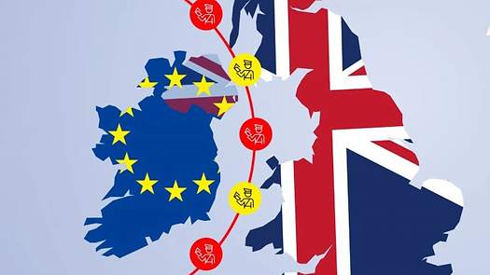
Northern Ireland has a truly special role in international trade. It is part of the United Kingdom but also shares a land border with the European Union through the Republic of Ireland. That position gives it a rare and powerful advantage, especially for food brands that want to supply both the EU and UK without the usual layers of complexity.

What Makes Northern Ireland So Special
When the United Kingdom left the EU, many businesses had to deal with new paperwork, customs checks, and costs. Northern Ireland, however, found itself in a very different place. Under the Northern Ireland Protocol and the Windsor Framework, the region follows EU rules for goods while remaining within the UK customs area. This means products made or distributed in Northern Ireland can move freely into both markets with minimal hassle or delay.
For food businesses, this dual access is a massive advantage. Northern Ireland’s goods meet EU food safety and labeling standards, allowing them to enter the European single market easily. At the same time, the UK Internal Market Scheme ensures products move smoothly into Great Britain. Whether it’s a Belfast bakery shipping to Manchester or a dairy company in County Down exporting to France, Northern Irish businesses enjoy flexibility that simply doesn’t exist anywhere else.

Goods Coming from Great Britain to Northern Ireland
For goods moving from Great Britain into Northern Ireland, things work a little differently. Under current rules, goods entering Northern Ireland are classified as either “at risk” or “not at risk” of being sent on to the EU market. If a product is considered “at risk,” it could face EU tariffs.

To manage this, the UK government introduced what is known as the Not at Risk Scheme, or UK Internal Market Scheme (UKIMS). This scheme allows registered businesses to declare goods as “not at risk” if they stay within Northern Ireland or elsewhere in the UK. In practice, that means companies bringing goods like packaged food, groceries, or retail items into Northern Ireland for use or sale locally can do so without paying EU tariffs.

For example, major supermarket chains use the scheme to move goods from distribution centers in England to stores in Belfast, ensuring shelves are stocked with familiar products. Manufacturers bringing in raw materials or ingredients for processing in Northern Ireland also benefit from the same arrangement. It’s a solution that keeps supply chains functioning and business costs under control.

Why This Matters for Food Brands
For food producers and exporters, timing and quality are everything. Northern Ireland’s unique position saves time, cuts costs, and removes the duplication that comes with maintaining compliance for two separate markets. This smooth trade flow supports both small artisan brands and large agri-food companies that rely on fast supply chains and predictable logistics.
The Northern Ireland Retail Movement Scheme also plays a key role in ensuring that retailers can stock the same food ranges available in the rest of the UK, maintaining consumer choice and price stability.

More Than Just Geography
Northern Ireland’s advantage is not only geographical. It has a skilled, English-speaking workforce, strong infrastructure, and a welcoming business environment that continues to attract investors. Over 1,500 international companies operate there, and many have used Northern Ireland as a strategic base to grow across the UK and Europe.
Leading firms like ‘Moy Park’ and ‘Dale Farm’ have built success around this dual market access. These companies are not just moving goods; they are building global reputations for quality, consistency, and trust. Their achievements show how powerful Northern Ireland’s dual access can be for food brands that think ahead.

How Businesses Can Benefit
• Move goods between Northern Ireland, the EU, and Great Britain without tariffs or long customs delays.

•Meet EU food safety standards once and gain access to both major markets.

• Use simplified processes under the UK Internal Market and Retail Movement schemes to keep operations efficient.

• Reach customers across 27 EU countries as well as the UK from one location.

• Reduce supply chain complexity and costs by centralizing production or distribution in Northern Ireland.

A Smart Choice for Businesses Beyond Northern Ireland
If your company is based elsewhere but serving both UK and EU customers, setting up in Northern Ireland can make trade much simpler. It allows smoother movement of products, fewer compliance headaches, and access to both massive markets from one well-connected base.
More and more businesses across different sectors are realizing that Northern Ireland can act as a bridge where UK and EU trade genuinely come together.

Northern Ireland connects two of the biggest markets in the world and makes trading between them easier than anywhere else. For food brands, this can be a turning point. The difference between slow, complicated export operations and a supply chain that simply works.

With the right customs advice and local knowledge, businesses can make the most of this position, secure market access, and grow with confidence on both sides of the Irish Sea.

If your business wants to explore the opportunities Northern Ireland offers, our team here at Customs Wise can help you understand the rules, simplify compliance, and guide you every step of the way.

